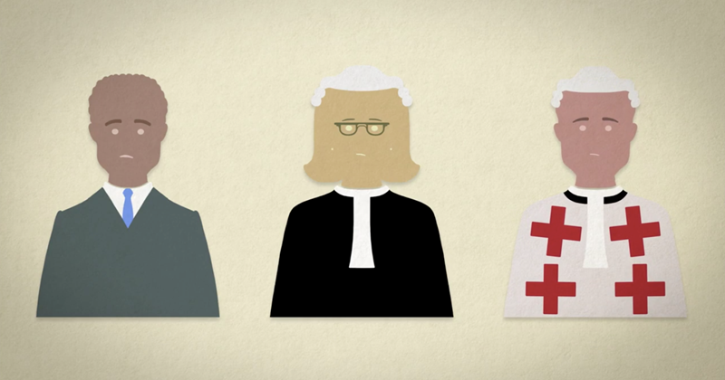

Electronic Tagging

Admonition

**Court:** Justice of the Peace

**Type of Crime:**

**Maximum Sentence:**

**Court:** Sheriff Court

**Type of Crime:**

**Maximum Sentence:**

**Court:** High Court

**Type of Crime:**

**Maximum Sentence:**

**SENTENCES**

**National 4**

**Crime and the Law**